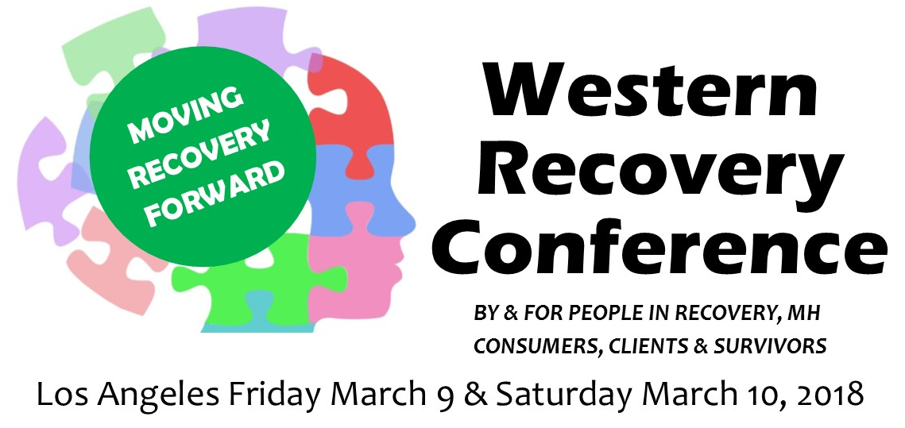 at SHARE! Culver City, 6666 Green Valley Circle Culver City CA 90230

Interested in presenting at the Western Recovery Conference in 2018?

• Submit workshops, roundtables, demonstrations, self-help support groups, etc.
• All sessions are either 50 or 75 minutes
• Presenters need to be registered for the Conference. For registration info, email WesternRC2017@gmail.com.

Please email the following to WesternRC2017@gmail.com as a Word document:
- Session Title:
- Presenters’ Name(s):
- Presenter’s Contact address:
- Presenter’s email:
- Presenter’s phone numbers (Required):

- Exact description of the session ready to put into the Program (no more than 50 words) and the length of presentation either 50 or 75 minutes—Required

7. Bio of each presenter in 3rd person ready to put into the Program (no more than 50 words)—Required of all except Self-help support groups

8. Statement of being a person in recovery, or with mental health issues, or a survivor. This will not be published or used for any other purpose—Required

9. Up to 2 pages of other info e.g. what people will learn, more presenters’ qualifications, further description of the proposed session and any other material you want to send—Optional

Thank you for your proposal submission!
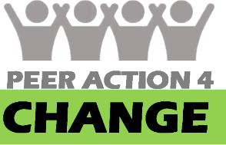
Peer Action 4 Change is a new voice for mental health consumers in Los Angeles to advocate on the local, state and federal levels.

