LA Regional Forum 11/22/19
Peers transform the Behavioral Health system
WHERE?  WHEN?  HOW TO REGISTER?*  WHO SHOULD ATTEND?  Interest in PAL? | Los Angeles County Region: venue at online registration  Friday, November 22, 2019; 9:30 am- 3:30 pm DATE CHANGE  (Sign- in & Networking at 9:00 am)  Forum Attendance Requires Online Registration:  https://camhpro-la-region-forum-nov-22-2019-peer-support.eventbrite.com  Peer Run Program/Agency Managers/Administrators, peer support staff, peers, Peer Action League Members—PALMs, County Administrators & all others welcome  ▪ Free Training ▪ Lunch Provided ▪ Limited Space! ▪ Register Now!  *Advance Requests for Translation or Accommodations Provided*  - Individual PAL Consumer/Peer Application  - Peer-Run Agency or Program PAL Application
PROGRAM | Our VISION: A voluntary, self-directed, community based behavioral health system with Peers & Peer Support leading the way  What are the essential elements? How do we get there? What do we need to do to get effective Peers to all decision-making tables with consequential Peer results?  - Peer Values, Principles & Positions  - Presentations on evidence of what's working and what's not working  - Panel on focused transformational goals from diverse communities  - Strategic collective action planning  ~ CONNECT & NETWORK ~ BUILD CAPACITY ~ REACH & REFLECT DIVERSITY ~
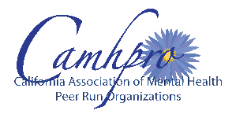  Presented by the California Association of Mental Health Peer Run Organizations (CAMHPRO)  IN PARTNERSHIP & COLLABORATION with SHARE! Emotional Health Assn. |  | Karin Lettau MS, Director of Training  klettau7@gmail.com ▪ http://camhpro.org/  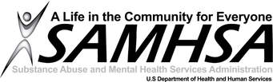  Funded by the U.S. Substance Abuse & Mental Health Services Administration (SAMHSA) State Consumer Network Grant.

