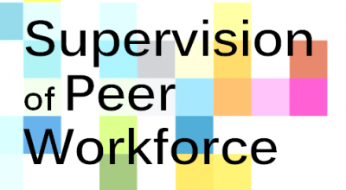

The Supervision of Peer Workforce Conference on Wednesday, March 25, 2020, which was presented virtually via Zoom, drew 592 registrants from 30 states and six other countries. Organized by SHARE! the Self-Help And Recovery Exchange, it featured 22 presentations. It was funded by the California Office of Statewide Health Planning & Development (OSHPD).
REGISTRANT INFO

